**ELECTRONIC DEVICES AND CIRCUITS LAB**

**OPEN ENDED LAB**

**STUDY AND IMPLEMENTATION OF AMPLIFIER CIRCUIT**

**OBJECTIVE**

* To Draw and Implement the Amplifier Circuit
* Enlist the components and Equipment to be used for Implementation

**TASK**

Your experiment should be designed to investigate:

* Suitable Transistor Configurations
* Drawback of Transistor Configurations you are not using

Your Expected Output should be like

Vin=1V and Vout=10V

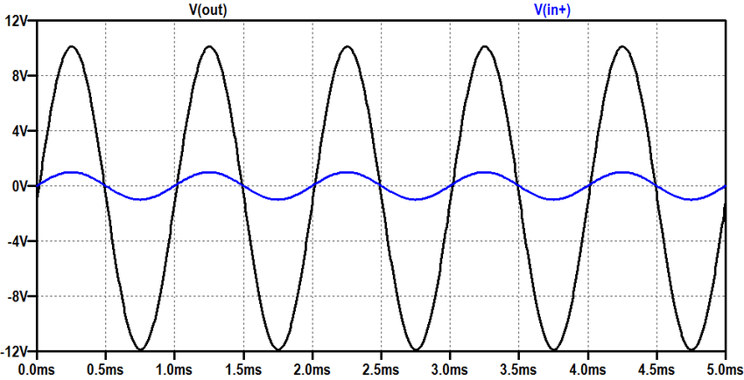

**LAB REPORT**

Your lab report should include the following sections

**PURPOSE**

* This is a statement of the problem to be investigated. It provides the overall direction for laboratory investigation and must be addressed in the conclusion

**EQUIPMENT**

* A list of all laboratory equipment used in the investigation
* A detailed and labeled diagram to illustrate the setup of the experiment

**List Of Equipments Used:**

🡪Vcc(20V)

🡪General Purpose Transistor NPN(2N3904)

🡪Resistors(10k $Ω$,500 $Ω$,500 $Ω$,10k $Ω$,100)

🡪Capacitor(10 $μF$,10 $μF$,100

🡪Function Generator

🡪Oscilloscope

**PROCEDURE**

* Step by step procedure carefully explained in a numbered sequence
* All experimental variables identified and named

**Procedure Adopt For The Implementation of Given Amplifier Circuit is:**

🡪Select all the equipments mentioned in the required equipments.

🡪Match the wires and nodes as in figure.

🡪Connect the function generator and oscilloscope.

🡪Run the Circuit and Notice the desired output.

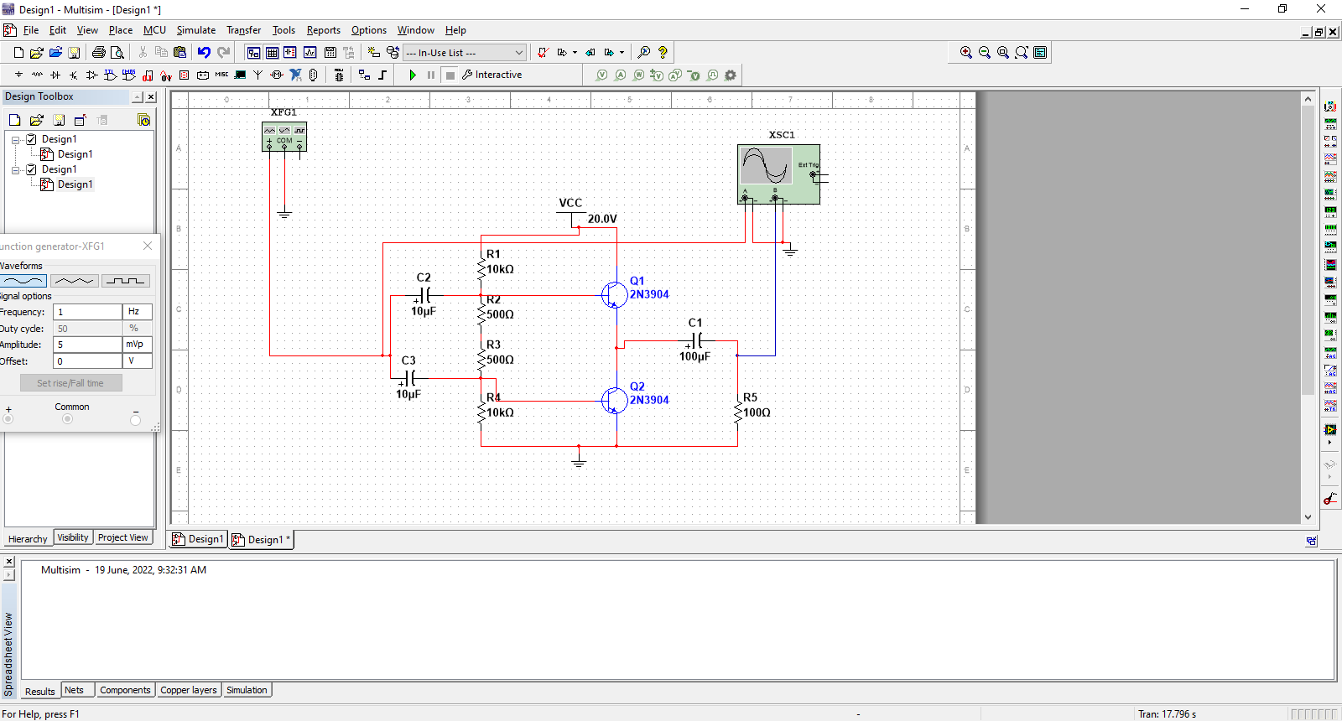

**DATA**

* What data needs to be taken for the Amplifier implementation and drawing region of operations
* The units of the measurements in the data table should be specified in the column heading only.

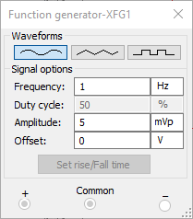

**DATA ANALYSIS**

* How do you interpret data?
* Include all graphs, analysis of graphs, laboratory calculations and percents error.

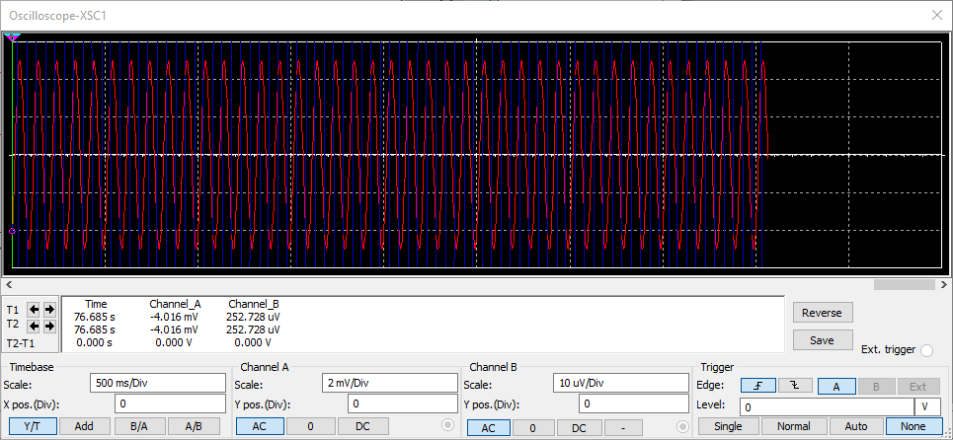

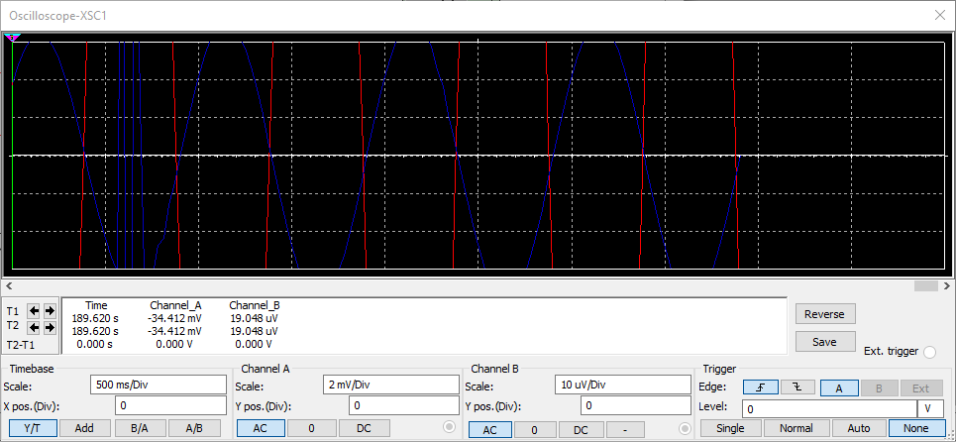

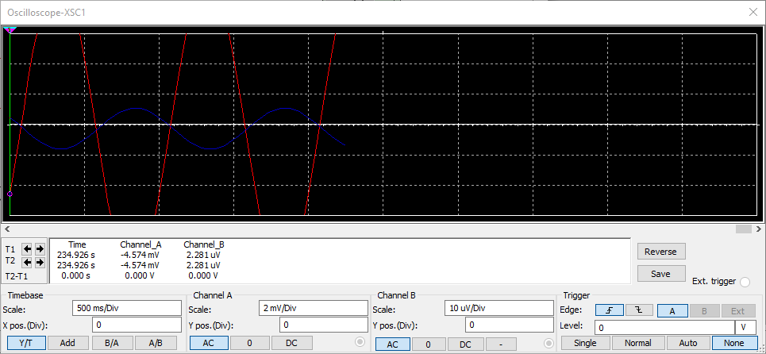

**CONCLUSIONS:**

* Discuss any questionable data or surprising results
* Explain the possible source of any error or questionable results.
* Suggest changes in experimental design that might test your explanations.

**Concluded Amplifier Circuit :**

**On Setting F=1 Hz, Duty Cycle= 50%, Amplitude= 5mVp**

